# Lab 2: Virtual Machines

## Microservices and Cloud Computing - CSC 5201 301

### Hudson Arney

### 16 September 2024

Why isn’t this (Erasing disk to install Ubuntu) scary?  
  
I think the main reason this is not scary is because the disk is currently empty/doesn’t have any useful information since we are just setting up. We are also installing everything that is important, new to it, so erasing any old data is less important.

Complete a beginners tutorial. Especially for using the command line. Take a screenshot. Ubuntu/Linux is popular for using containers.

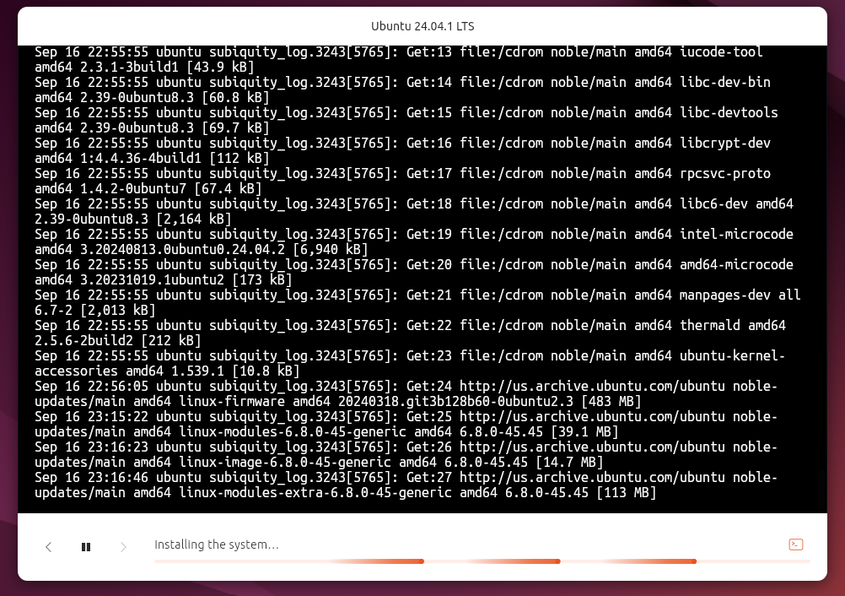

Currently installing which is taking longer than 40 minutes at this point…

Do something more useful or entertaining on Ubuntu than I did below. And take a screenshot.

FINALLY INSTALLED (1 hr: 20min later)!!!

I ran ls -l to check the files and directories with their respective read/write permissions

Uname -a to display detailed information about the system (kernel version, system architecture, etc.).

And finally df -h to show how much disk space is used and available in human-readable format.

This gives me a better insight of the machine and so far it is running smoothly!

**Post Lab Thoughts**

**Challenges/Feedback**: I thought this lab was straightforward. I had the most trouble with downloading Ubuntu onto the VM as it took much longer than expected. I’m excited to use this VM on other projects!

This summer I worked for a remote company and used a Cloud Computer through Windows 365 Cloud. It was really useful, and although it was a bit annoying to sign into every morning, was a bit more relaxing than having to haul around another physical computer.

Like the last lab I appreciated all the screenshots and descriptions of every step. Only criticism I would give is to give a bigger disclaimer on how long it takes Ubuntu to install onto the VM (unless I did something wrong and it took far longer than it should have). I know you did say grab 2 coffees lol… Gues I should have listened.